Diary Products Sales Analysis with Excel and Power BI
1. Project Overview and Objective
This project involves cleaning, transforming, and analysing raw data using Excel and creating an interactive Power BI dashboard to derive meaningful business insights.
The main objective is to demonstrate data pre-processing techniques using Excel and an interactive Power BI dashboard visualization to make informed decisions.

2. Data Sources
- Source Description and Timeline: ExcelX.com Diary Products Sales 2025
- Domain: Sales Analytics

3. Problem Statement
- To analyse sales performance across regions and products to identify top-performing areas and profit trends.
- To study Sale patterns across states and years for better Sales.

- To evaluate Store performance and attrition factors for improved Business decision Making.
- To understand Product Sales Insights to enhance marketing and retention strategies.

4. Attribute (Column /Features) Details:
Attribute Name | Data Type | Description
Order_ID | Integer / String | Unique Identifier for each sales Order
Order_Date | Short Date | Date of the order
Product_ID | Integer / String | Unique Identifier for each Product
Product_Name | Categorical | Name of the Product
Category | Categorical | Name of the Product Category
Store_ID | Integer / String | Unique Identifier for each Store
Store_Name | Categorical | Name of the Store
City | Categorical | City Name where the store located
District | Categorical | District Name where the store located
Sales_Channel | Categorical | Type of Sales
Quantity | Numeric (Whole number) | Quantity of the product in each order
Unit_Price | Numeric (Currency) | Price of the Product in each order
Discount_Percent | Numeric (Percentage) | Discount given for Each Order
Payment_Mode | Categorical | Type of payment methods
Total_Amount | Numeric (Currency) | Total Amount in Each order
Sales_Category | Categorical | Type of Sales categories

5. Tools & Technologies
- Excel: Data cleaning, transformation, and Pivot Tables.
- Power BI: Data modelling, DAX calculations, visualization, and interactive dashboard creation.

6. Data Pre-Processing (Excel / Power Query)
Tasks Performed:
- Data Cleaning & Transformation: Removed duplicates, handled missing values, standardized formats, and created calculated fields.
- Filtering & Sorting: Organized data to focus on relevant records.

7. Data Modelling and DAX (Power BI)
- Data Model: Established relationships between tables, defined cardinality, and created lookup tables where necessary.
- 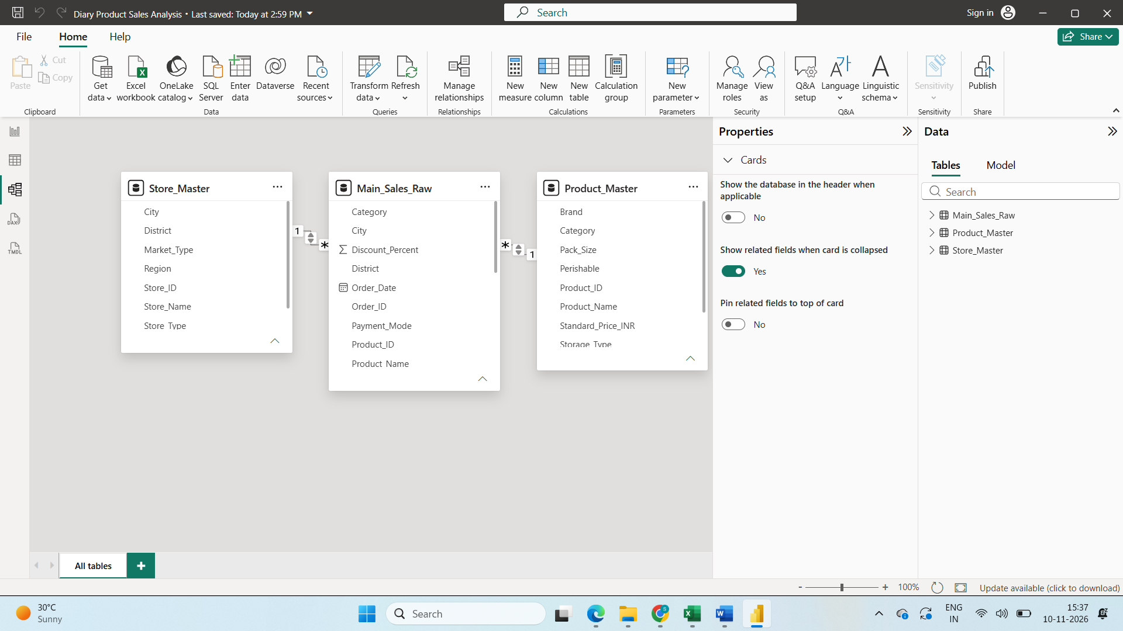Calculated Columns & DAX Measures: Implemented DAX formulas for key metrics, such as total sales, growth percentages, and cumulative totals profit and loss

8. Analysis and Visualizations (Power BI)
Dashboard Features:
- Multiple Visualizations based on problem statement: Bar charts, line charts, pie charts, Donut Charts, Stacked Bar Charts, Stacked column charts, Map Charts, Gauge Charts, Tree Map Charts, Cards, etc. to communicate insights
- Used slicers to highlight the categories
- Dairy Product Sales Analysis Dashboard

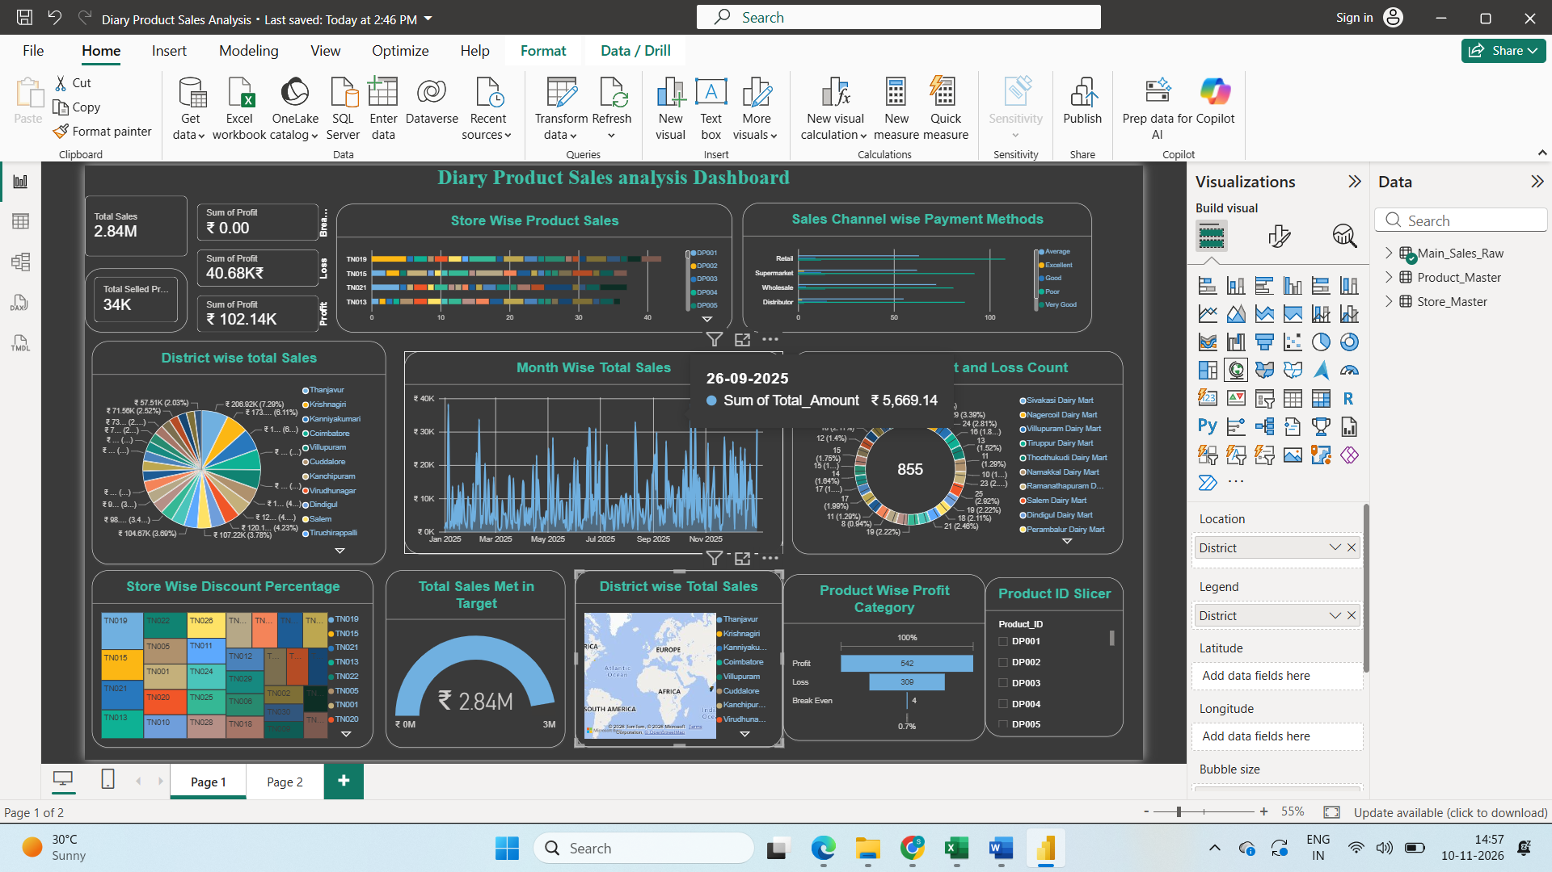
- Product and Store Insights Dashboard

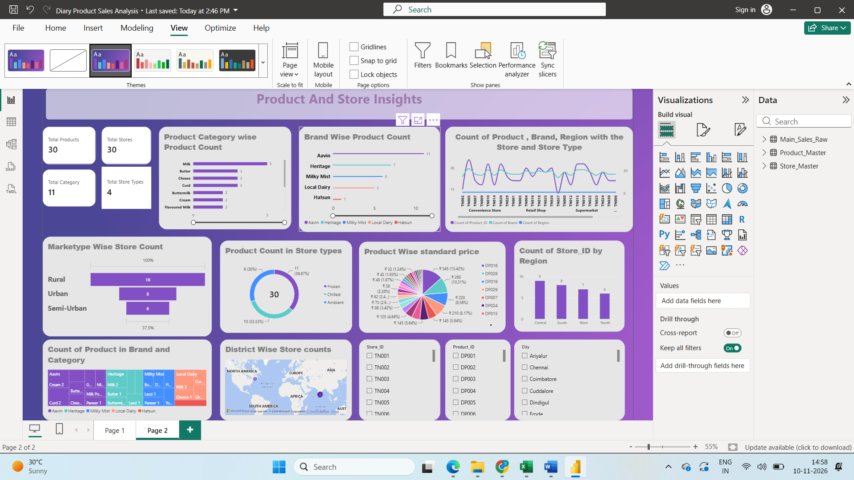

9. Insights & Conclusions
- Key Findings: Summarize trends, patterns, or anomalies identified in the data
- Provide the analysis insights:
    - Descriptive
    - Diagnosis
    - Predictive
    - Prescriptive
10. Conclusions
The integration of Excel and Power BI proved effective for end-to-end data analysis, from raw data to visual reporting.

